AMERICAN INTERNATIONAL UNIVERSITY-BANGLADESH
Faculty of Science and Technology
Department of Computer Science
CSC 3215: Web Technologies
Semester: Summer 2025-26 Group No: 05 Section: U
Group Members:
SL. | Student ID | Name | Role | Signature
1 | 23-54538-3 | MD. NUMMAN | Group Leader
2 | 23-54558-3 | RIYA AKTER | Member
3 | 23-54199-3 | NAWSHIN SAIYARA | Member
4 | 23-54573-3 | SURAIYA BARI ADIBA | Member
Project Title
Abroad Management System
Short Description
This project is a centralized, automated web-based platform designed to bridge the operational gap between study abroad aspirants, education consultancy agencies, global universities, and system administrators. The system streamlines the complete student recruitment lifecycle—from university program exploration, eligibility assessment, IELTS/GRE mock testing, and consultancy service booking to 5-stage student pipeline tracking, university admission evaluation, and scholarship disbursement. Built upon pure procedural PHP and MySQL (following a clean Model-View-Controller architecture with prepared statements), it eliminates manual paper friction and provides an automated financial commission split mechanism.
Introduction
Higher education abroad has witnessed exponential growth, leading to complex multi-stakeholder interactions among students, consultancy firms, and international institutions. Currently, students face fragmented information across disconnected agency websites, opaque fee structures, and cumbersome manual document tracking. Conversely, agencies struggle with client pipeline visualization and revenue calculations, while university admissions offices lack streamlined applicant vetting. AbroadHub solves these challenges by providing a unified, secure portal where all four actors collaborate seamlessly with real-time updates and cryptographic security.
Background Study
A comprehensive study of existing international education platforms (such as IDP, Shiksha, and ApplyBoard) reveals significant operational limitations for independent regional agencies and students. Existing commercial solutions either impose prohibitive subscription fees on boutique consultancies or lock students into singular agency ecosystems without transparent comparative catalogs. Furthermore, regional applicants lack integrated departure preparation tools (such as flight buddy synchronization) and local currency-adjusted financial ledgers. AbroadHub addresses these specific domain shortcomings by offering transparent multi-agency service comparison, automated 90%/10% escrow-style revenue distribution, real-time mock test scoring, and peer networking.

ER Diagram

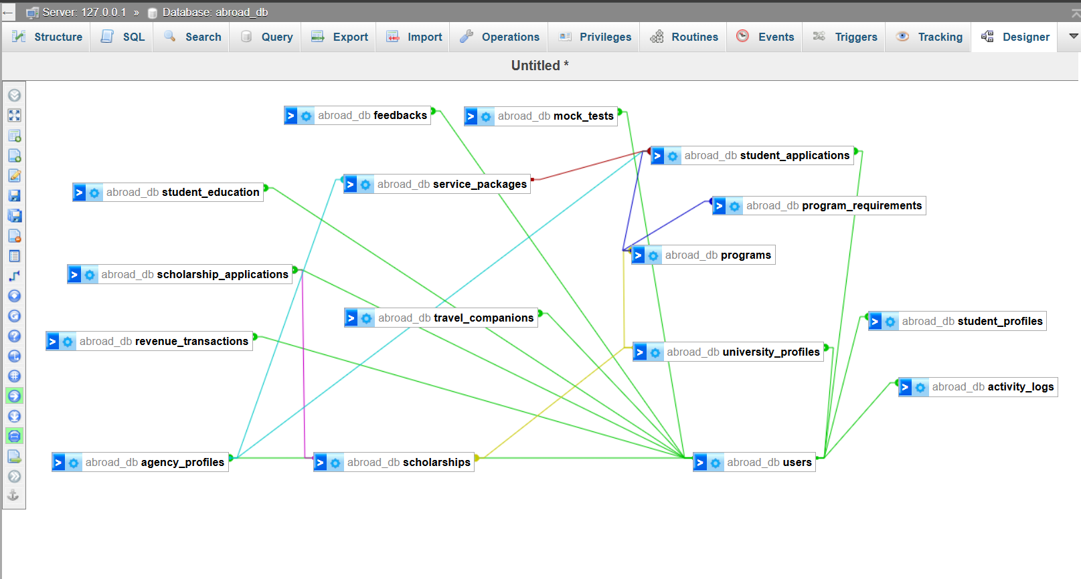

Figure 1: ER Diagram

Use Case Diagram

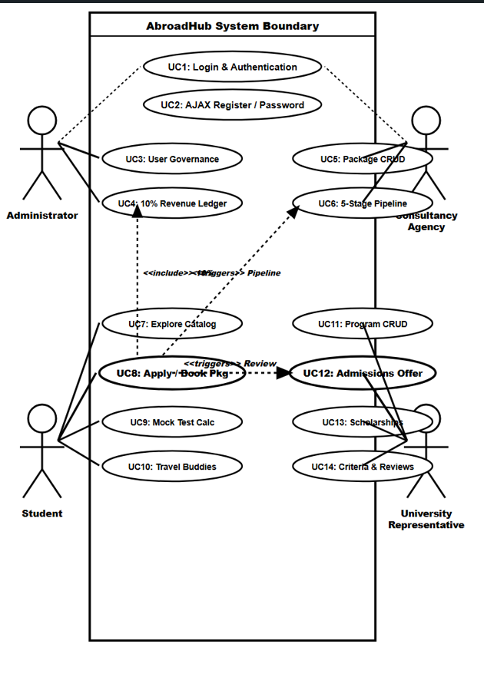
Figure 2: Usecase Diagram

UI (Tentative Design & User Interfaces):

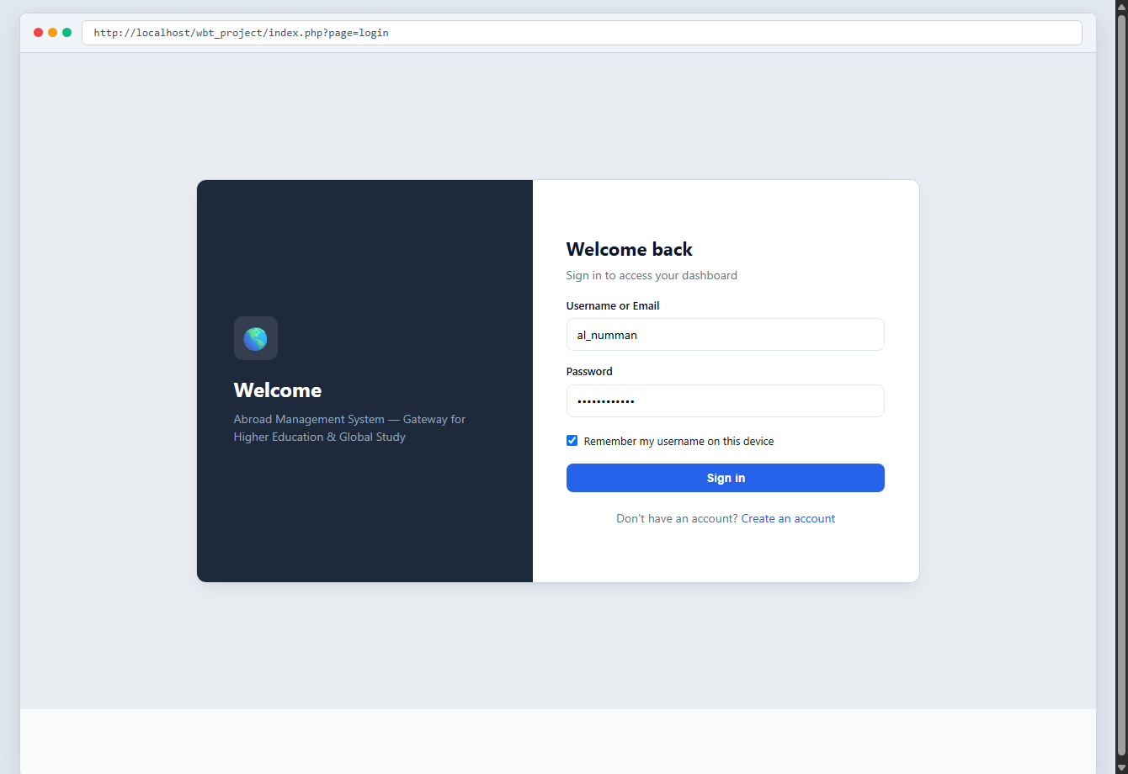
Figure 3: User Authentication & Sign-in Interface (views/auth/login.php)

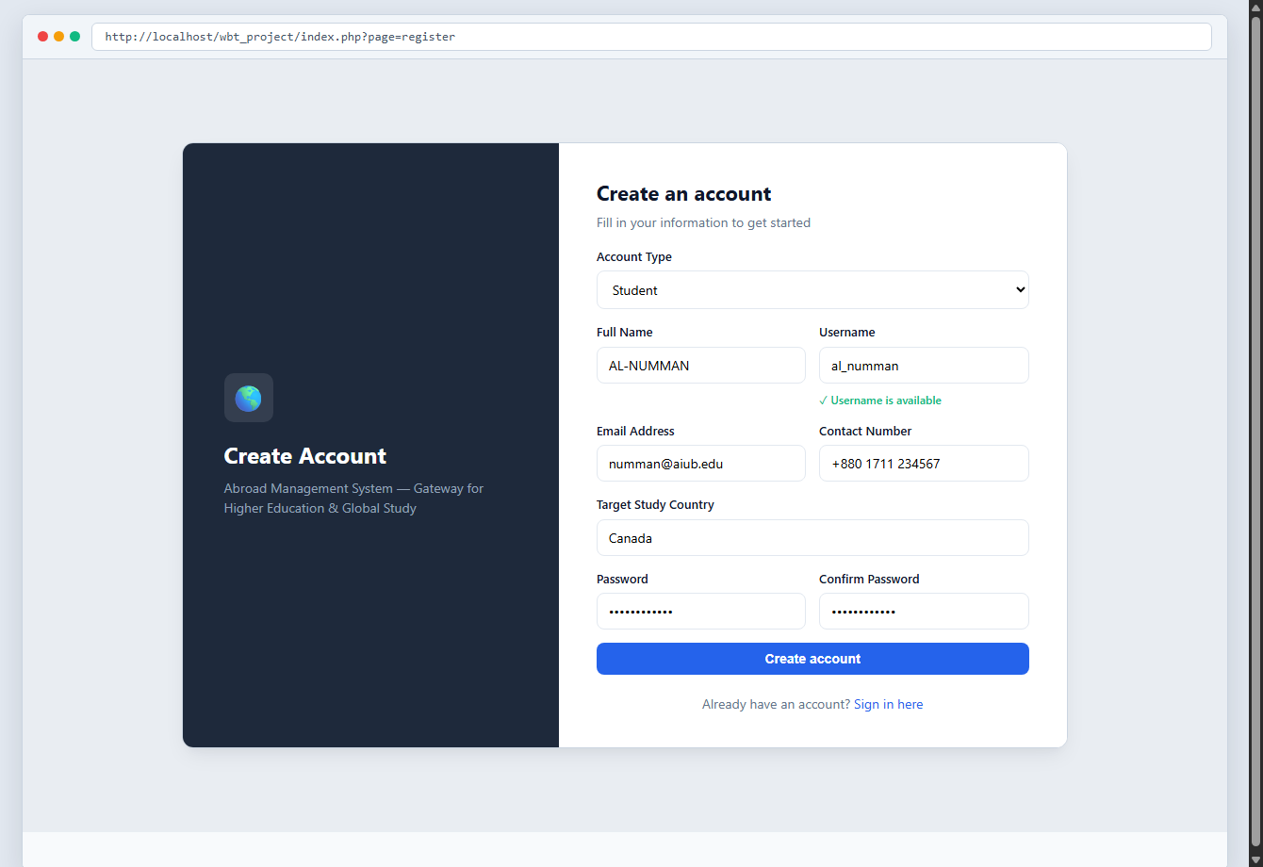
Figure 4: Role-Adaptive User Registration Portal (views/auth/register.php)

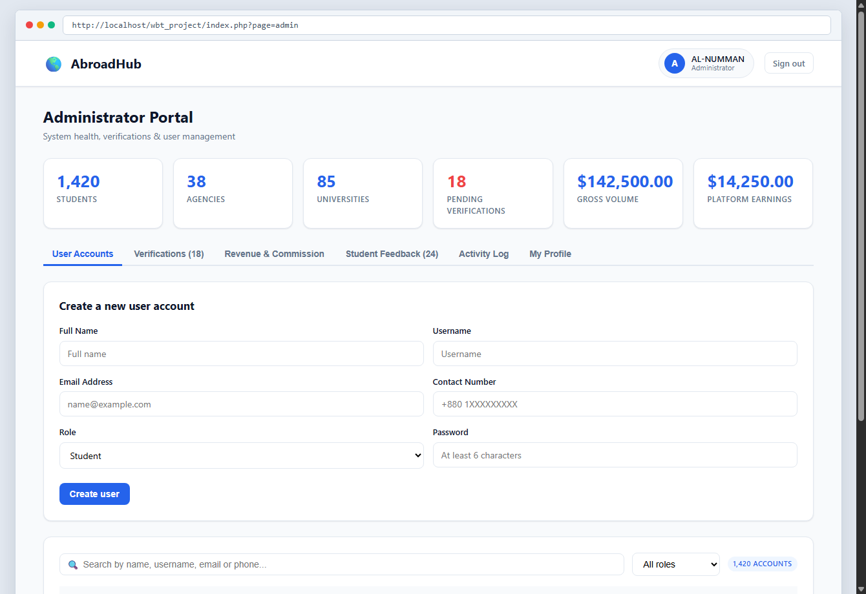
Figure 5: System Administrator Control Portal (views/admin/dashboard.php)

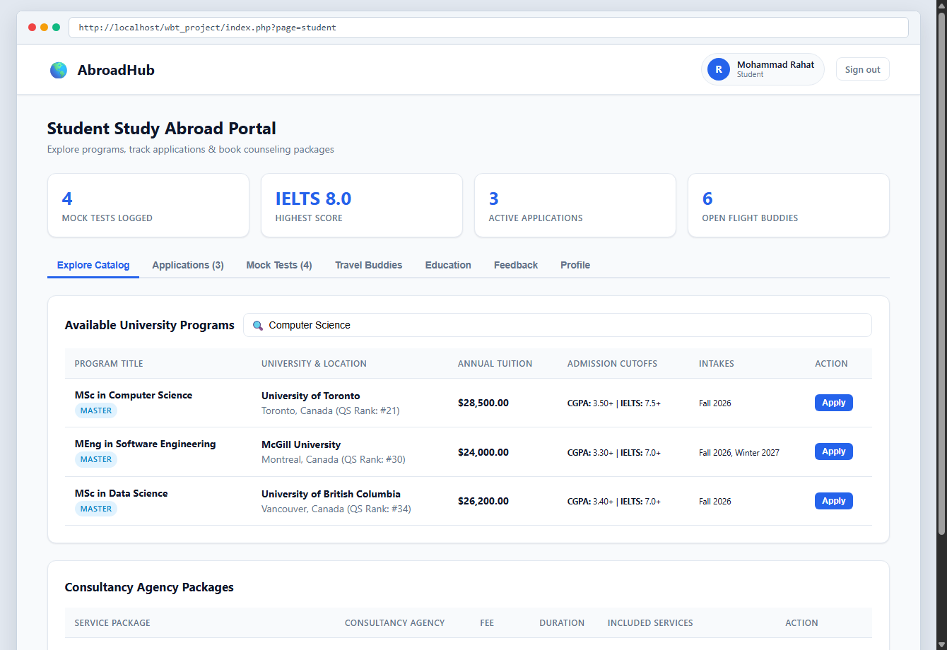
Figure 6: Student Study Abroad & Program Explorer (views/student/dashboard.php)

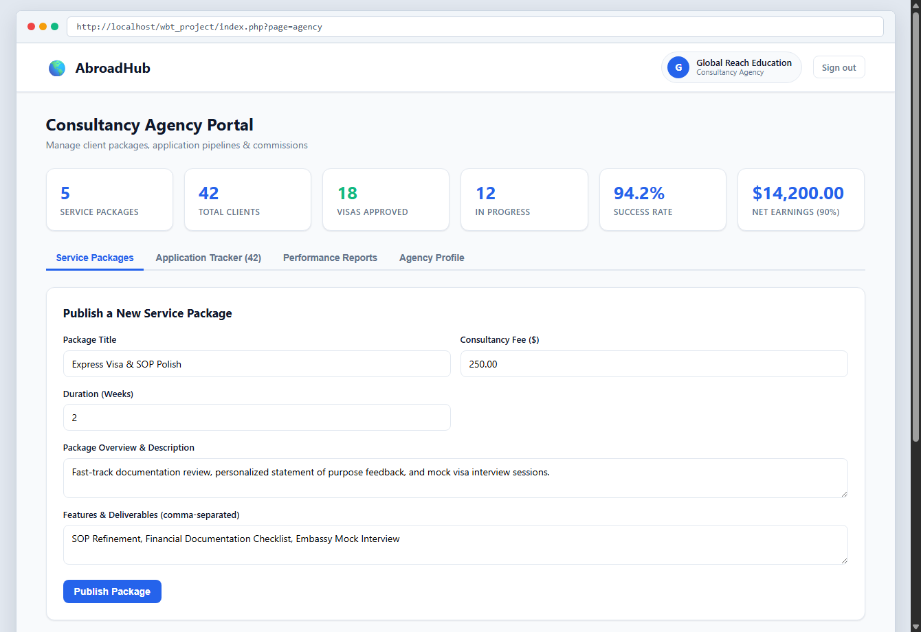
Figure 7: Consultancy Agency Client Management Portal (views/agency/dashboard.php)

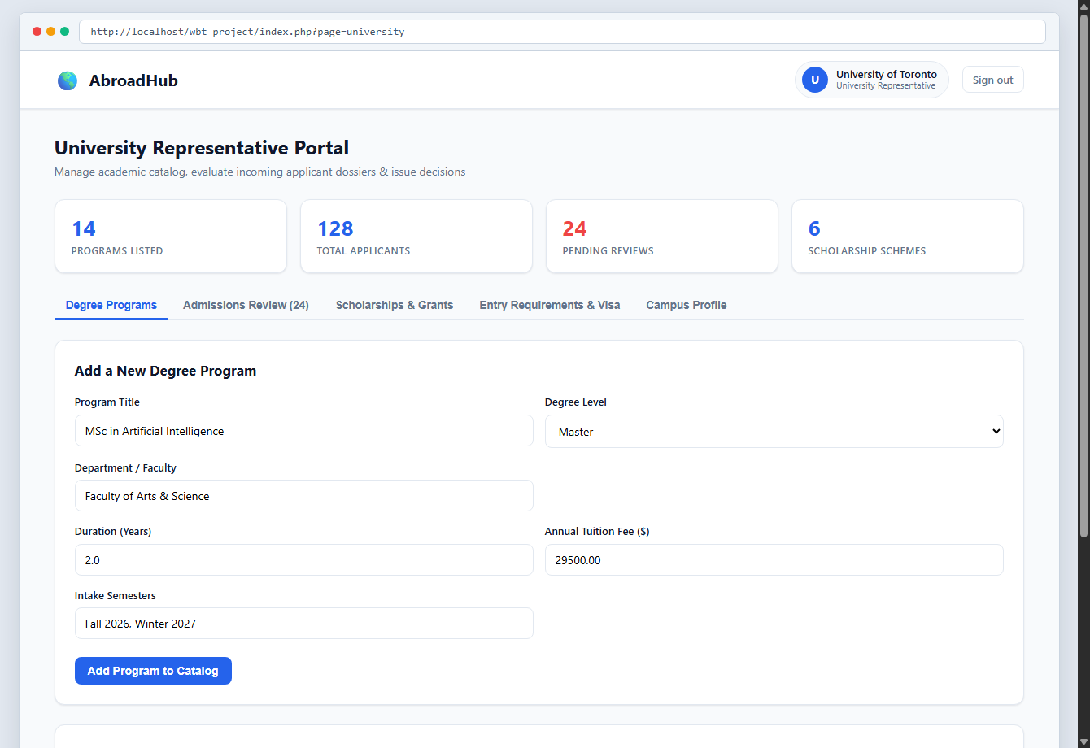
Figure 8: University Representative Admissions Review Portal (views/university/dashboard.php)

Types of Users: 1. Administrator (Admin) 2. Student (Applicant) 3. Consultancy Agency 4. University Representative
Common Features (Available to All Users)
● Authentication: 1. Login to the system with username/email and password.
2. Logout from the system with complete session invalidation.
3. User registration with role-specific profile attributes and real-time AJAX username availability check.
● Account Management: 1. Change or reset password with current password verification and BCrypt hashing.
2. Manage and update profile information (contact details, address, biography, passport/license).
● Dashboard: 1. Access a personalized, role-guarded dashboard with live statistical summary cards after authentication.
Specific Features by User Type
● Features of User 1: Administrator (Admin)
1. User Account Governance & Status Control: Comprehensive CRUD operations on all user accounts with instant account suspension/activation control without data loss.
2. Automated 10% Platform Revenue & Commission Ledger: Automated financial ledger recording student package bookings, automated 10% platform commission earnings, and gross transaction volume.
3. System-Wide Security Audit Trail Log: Real-time chronological audit trail capturing all user logins, status modifications, and system operations with keyword search.
4. Institutional Verification Management (Bonus): Reviewing agency trade licenses and university accreditation files to approve or reject institutional partner verifications.
● Features of User 2: Student (Applicant)
1. Unified Degree Program & Agency Service Catalog: Interactive explore catalog filtering global university programs and agency packages with 1-click application submission.
2. IELTS / TOEFL / GRE Mock Test Band Calculator: Online exam simulator providing interactive practice with automated band score calculation across Reading, Writing, and Listening.
3. Travel Buddies Community Finder: Peer departure networking platform matching students traveling to the same country/city by flight schedule and departure dates.
4. Academic Record Vault & Service Feedback (Bonus): Multi-qualification academic record manager and 5-star rating/feedback submission system for consultancy services.
● Features of User 3: Consultancy Agency
1. Service Package Management & Publishing (CRUD): Complete creation, pricing configuration, and instant publishing of consultancy packages (Visa Processing, Counseling, File Opening).
2. 5-Stage Student Application Pipeline Tracker: Visual milestone pipeline managing student files across 5 distinct stages: Counseling → Document Verification → University Applied → Visa Processing → Enrolled.
3. Automated 90% Net Earnings & Statements: Financial analytics interface tracking gross client booking volume, platform commission deductions, and net 90% agency revenue.
4. Client Review & Service Quality Monitor (Bonus): Direct monitoring of student star-ratings and client feedback to evaluate consulting performance.
● Features of User 4: University Representative
1. Degree Program & Tuition Fee Management (CRUD): Comprehensive management of degree program offerings, degree levels (Bachelor/Master/PhD), duration, and annual tuition fees.
2. Intake Admissions Review & Offer Letter Decision Portal: Admissions portal to evaluate student applicant dossiers, examine credentials, and issue official admission decisions (Under Review, Accepted / Offer Letter, Rejected).
3. Scholarship Schemes Creation & Merit Awarding: Creation of institutional scholarship schemes (Full/Partial waivers), evaluation of student statements of purpose, and awarding grants.
4. Program Entry Criteria & Visa Thresholds (Bonus): Configuring program entry requirements, minimum CGPA thresholds, IELTS/TOEFL requirements, and international visa criteria.

